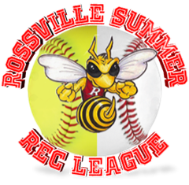
Rossville Baseball Softball Summer Rec League
Concussion Protocol

Purpose
The purpose of this document is to outline the Rossville Baseball Softball Summer Rec League (RBBSRL) concussion protocol for all participants. Through this document RBSSRL strives to empower coaches and parents with information to recognize concussion symptoms and educate them on the importance of early detection. This document will also serve as a guideline for actions to be taken if symptoms are observed.

Information
A concussion is a type of traumatic brain injury that occurs when the brain moves within the skull as a result of a bump, blow, or jolt to the head or by a hit to the body that causes the head and brain to move rapidly back and forth. This type of injury disrupts normal function of the brain and can have lasting effects if not properly treated.

Recognition and Management
After an bump, hit, or jolt a child or teen may report one or more of the symptoms shown below or you may observe others. It is important to recognize that symptoms may take several days to show up. If a participant experiences an injury but shows no immediate symptoms, parents should continue to monitor their child for a few days after the initial injury.
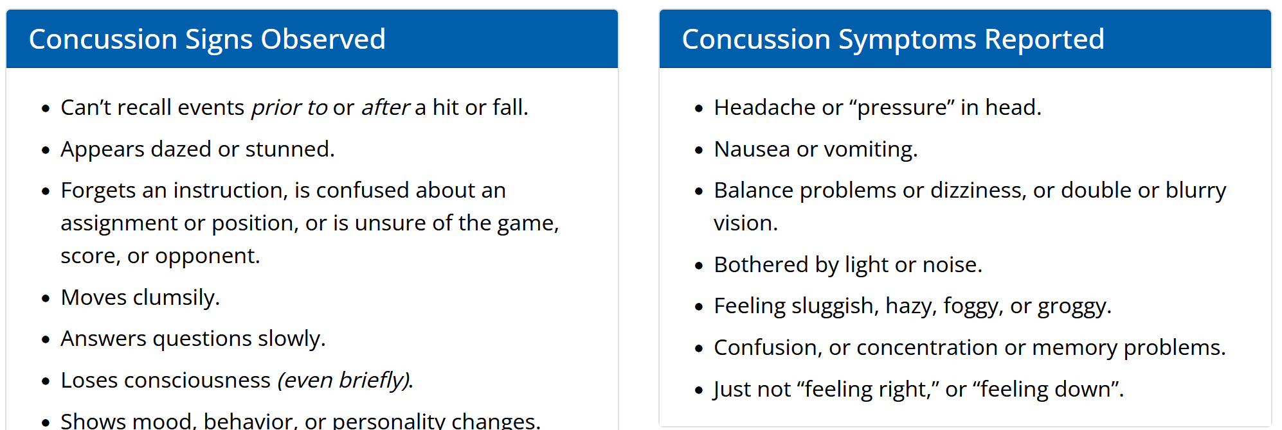
Immediate emergent care should be sought if the following signs or symptoms are observed as they are indicative that a hematoma (collection of blood) may be forming under the skull causing compression on the brain.
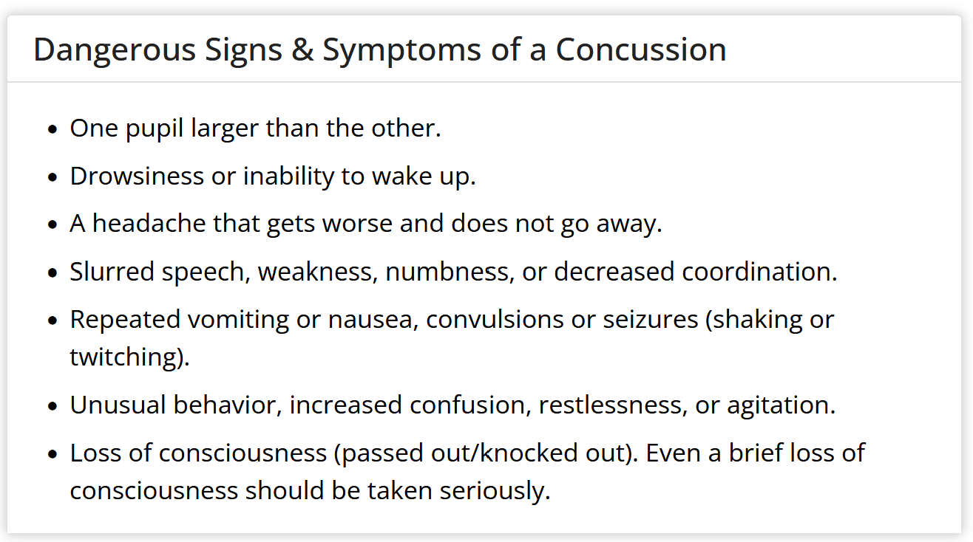

Injury Protocol
RBSSRL will follow all CDC guidelines for injuries that may result in concussion. Any participant that is suspected to have a concussion or is observed to have symptoms will be removed from play immediately for evaluation. The coach and parent shall work together to evaluate the participant for concussion signs both observed and reported. If there is suspicion of a concussion the participant will be kept out of play and referred to see a medical practitioner. The coach will report the injury and outcome to the relevant program coordinator or board member for recording purposes.

Return to Competition
The participant may return to practices and competition when symptom free and a medical provider provides clearance to play. It is important to note that clearance for school is not the same as clearance to resume sport activities and returning to full competition may be a multi-step process as determined by the participant’s medical provider.

Prevention
In an effort to safeguard participants in all programs offered by RBSSRL the following rules have been implemented:
- All softball participants will wear a faceguard regardless of age level and/or position played
- All softball batting helmets must have a full face guard on them
- Baseball helmets must have a cheek guard or full face guard as defined by league rules and age level

Adherence to Rules
All rules for concussion protocols and safety preventions are reviewed yearly to ensure full compliance with league rules and in recognition that research pushes new information on a regular basis. As safety is of the utmost importance, RBSSRL retains the right to dismiss a participant from the program if concussion protocol is broken or if safety rules are not followed.

Resources
www.cdc.gov/headsup

